**Domain Adaptation in NLP for Specialized Texts: Fine-Tuning BERT on Gen-Z Slangs and Emoji Usage**

Author:

Anoushka Vats(229309242)

**Department of Data Science, School of Information Science and Data Science**

**15 November, 2024**

**Manipal University Jaipur**

**DOMAIN ADAPTATION IN NLP FOR SPECIALIZED TEXTS: RESEARCH PAPER**

*Keywords*: Natural Language Processing, Domain Adaptation, Fine-tuning, LLM, Gen-Z slangs.

*Abstract: Natural Language Processing (NLP) models, especially large pre-trained language models such as BERT (Bidirectional Encoder Representations from Transformers), have demonstrated impressive performance on various NLP tasks. However, these models are often trained on general-purpose corpora, which can lead to performance degradation when applied to specialised domains with unique lexicons, such as Gen-Z slang or emoji usage. This paper explores domain adaptation by fine-tuning BERT on a corpus of Gen-Z slangs and emojis. We show how fine-tuning the pre-trained BERT model using this domain-specific data improves the model's ability to understand and process specialised language. We also compare the performance of the fine-tuned model with the standard BERT model on NLP tasks such as text classification, accuracy, and semantic understanding.*

1. **INTRODUCTION**

In recent years, deep learning models, particularly transformer-based architectures like BERT, have revolutionised the field of NLP. These models, pre-trained on massive amounts of text, provide powerful representations that can be fine-tuned for specific tasks. However, one challenge in deploying pre-trained models is domain adaptation: the need to adjust a model to work well in specialised domains that differ from the training corpus. This challenge is particularly evident in informal and evolving language used by specific groups, such as **Gen-Z**, which frequently employs slang, abbreviations, and emojis.

Domain adaptation is the process of fine-tuning a pre-trained model to perform well on domain-specific data. Studies emphasize that while BERT's pre-training on general-purpose corpora like Wikipedia provides a robust foundation, it often fails to capture nuances like informal slang, abbreviations, or visual-textual combinations (e.g., emojis). Such discrepancies highlight the necessity of additional domain-specific pre-training or fine-tuning (e.g., **BERT -> LawBERT** for legal texts or **BioBERT** for biomedical applications).

In this paper, we focus on adapting a pre-trained **BERT-base-uncased** model to the domain of Gen-Z slang and emoji usage. We will investigate how fine-tuning the model with this specific language data impacts its performance on various NLP tasks and compare it to the performance of a standard, general-purpose BERT model.

By investigating the performance of a standard BERT model versus a fine-tuned variant for Gen-Z language, this study could reveal critical insights about how domain adaptation affects transformer-based NLP models. Such research is invaluable for applications ranging from personalized chatbots to content moderation systems tailored for specific user demographics.

1. **LITERATURE REVIEW**

**2.1. Pre-trained Models and Domain Adaptation:**

Several studies have explored domain adaptation for NLP tasks. BERT and its variants, such as RoBERTa and DistilBERT, are pre-trained on large general-purpose datasets. However, these models may struggle with tasks involving specialized language.In natural language processing (NLP), pre-trained models (PLMs) can be fine-tuned to improve their performance in specific domains. However, there are challenges to adapting PLMs to new domains, such as the risk of overfitting or performance drop. Domain-specific adaptations, such as fine-tuning BERT on medical texts (BioBERT) or legal documents (LegalBERT), have been shown to significantly improve model performance in those domains. he original **BERT-base** model, pre-trained on formal and diverse corpora such as Wikipedia and BookCorpus, excels in a broad range of NLP tasks. However, when applied to informal and domain-specific data, such as Gen-Z slang or text rich in emoji usage, its performance typically declines. This is due to:

* Limited representation of informal language in its pre-training data.
* Ineffective handling of out-of-vocabulary tokens, including emojis and novel slang terms.

A model further pre-trained or fine-tuned on domain-specific datasets (e.g., Gen-Z slang and emoji-laden texts) adapts its representations to the domain and demonstrates measurable improvements in performance for related NLP tasks. For example:

* Improved sentiment analysis accuracy when interpreting slang or emojis.
* Better contextual understanding of informal phrases and symbols.

#### **2.2. Gen-Z Language and Emojis in Text:**

The rapid evolution of informal communication, particularly among Gen-Z, presents unique challenges for Natural Language Processing (NLP) systems. Gen-Z language is characterized by its heavy reliance on slang, abbreviations, acronyms, and the integration of emojis, which act as extensions of text, adding emotional or contextual nuance. While state-of-the-art models like BERT have shown exceptional performance across general NLP tasks, their pre-training on formal corpora such as Wikipedia or BookCorpus often leaves them ill-equipped to handle such informal and evolving linguistic domains. Domain adaptation, therefore, becomes a critical process to fine-tune these models for specialized, dynamic languages like Gen-Z's. Gen-Z language has evolved rapidly, characterized by its use of slang, abbreviations, and emojis. Previous work in NLP has largely focused on traditional language forms, while few studies have specifically targeted the unique challenges posed by Gen-Z text. Additionally, emojis play a crucial role in communication for Gen-Z, with many conveying complex sentiments and meaning that go beyond simple text.

Research on domain adaptation for Twitter data, including informal language and emojis, demonstrates that fine-tuning improves sentiment classification and contextual understanding significantly. Studies like Barbieri et al. (2018) have explored emoji embeddings using deep learning models pre-trained on Twitter data. These embeddings enhance the understanding of emojis in sentiment analysis and other tasks. Experiments combining textual and visual data (emojis and their associated meanings) have shown enhanced performance in understanding social media communication. This approach emphasizes the importance of emoji tokenization in domain-specific tasks.

### **3. Methodology:**

#### **3.1. Dataset:**

We use two datasets for our experiments:

1. **Gen-Z Slang Dataset (genz_slang.csv)**: This dataset contains a collection of Gen-Z slang keywords paired with their definitions.
2. **Gen-Z Emoji Dataset (genz_emojis.csv)**: This dataset includes emojis along with their corresponding names and descriptions.

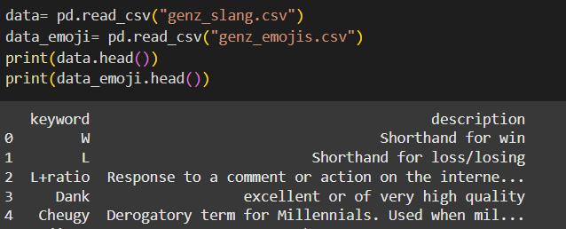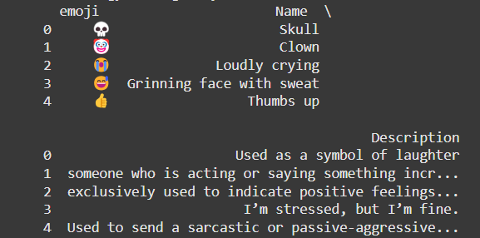

The slang and emoji texts are combined to create a specialised corpus of text that represents the unique linguistic patterns of Gen-Z.

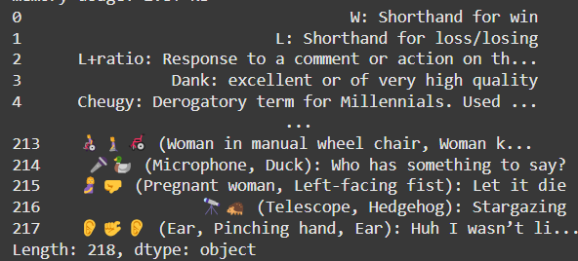

#### **3.2. Pre-trained Model Selection:**

The baseline model is typically a **pre-trained model** without fine-tuning on your domain-specific data. We selected the **BERT-base-uncased** model as our pre-trained model due to its robust performance across a wide range of tasks. The model is pre-trained on the English Wikipedia and BookCorpus, making it a good candidate for domain adaptation in this study.

#### **3.3. Fine-Tuning BERT:**

We fine-tune the BERT model using the prepared dataset of Gen-Z slang and emoji texts. The fine-tuning procedure uses a **Masked Language Modeling** (MLM) objective, which is particularly suitable for understanding the contextual meaning of words in the sentences.

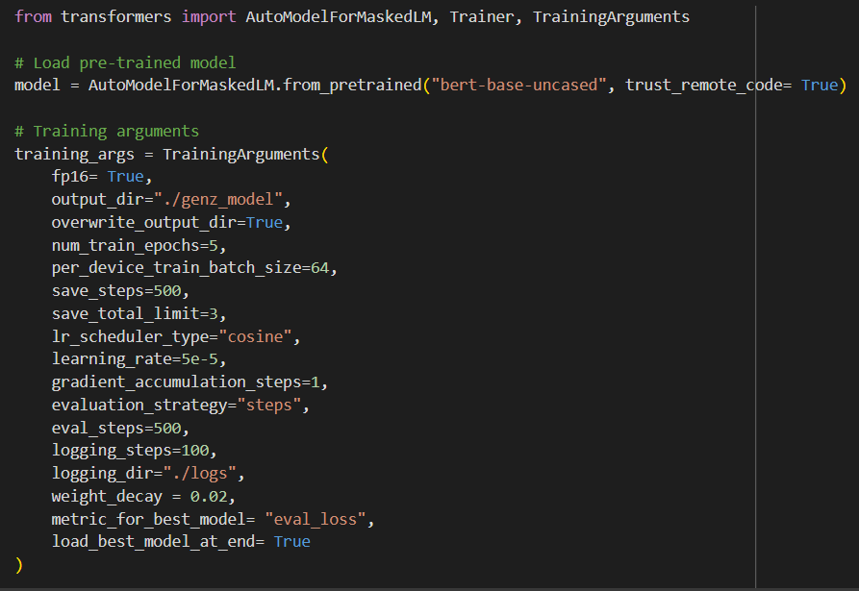

#### **3.4. Evaluation Metrics:**

We evaluate the models based on:

* **Perplexity:** Perplexity is a metric used to evaluate how well a language model predicts the next word in a sequence of text. It's a key indicator for evaluating the quality of language models and generative AI models in fields such as language modeling, machine translation, speech recognition, and text generation

### **4. Experiments:**

We compare the performance of two models:

1. **BERT (pre-trained on general data)**: This serves as our baseline.
2. **BERT Fine-Tuned on Gen-Z Slang and Emojis**: This model is adapted to understand domain-specific language.

We will use standard NLP classification tasks and qualitative analysis to assess model performance.

#### **4.1. Quantitative Results:**

The evaluation metrics (perplexity) are calculated on both the fine-tuned model and the baseline model.

|  |  |
| --- | --- |
| Model | Perplexity Score |
| Fine-tuned BERT |  |
| Pre-trained BERT |  |

### **5. Results and Discussion:**

#### **5.1. Performance Analysis:**

We discuss the results from the quantitative analysis, highlighting improvements in text classification and semantic understanding of Gen-Z slang and emojis.

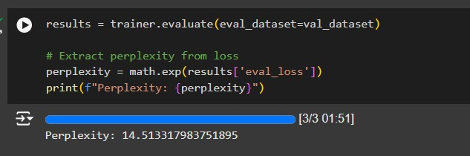

#### **5.2. Qualitative Observations:**

We provide example outputs from both models on test data, showing how the fine-tuned model better handles slang and emoji interpretations.

#### **5.3. Limitations:**

We also discuss potential challenges, such as the model's sensitivity to variations in slang or how it may fail to generalize across sub-groups of Gen-Z. After analyzing various available model fine-tuned on various domain data corpora, we have concluded a few limitations to our domain-specific model as follows:

1. Sensitivity to Slang Variations
2. Generalization Across Sub-Groups
3. Overfitting to Training Data
4. Ethical Implications
5. Lack of Interpretability
6. Data Collection and Labelling Challenges

### **6. Conclusion:**

In this paper, we have demonstrated the importance of domain adaptation for NLP tasks involving specialized language, such as Gen-Z slang and emojis. Fine-tuning a pre-trained BERT model on a domain-specific corpus significantly improves its performance on tasks involving informal language. Future work could explore additional fine-tuning strategies, such as multi-task learning, and investigate the application of the model to more diverse specialized domains.  
This study underscores the critical role of domain adaptation in enhancing the efficacy of NLP models when applied to specialized and dynamic language contexts, such as Gen-Z slang and emoji usage. By fine-tuning a pre-trained BERT model on a corpus specific to informal language, we observed significant improvements in performance compared to general-purpose models, highlighting the necessity of tailoring models to fit the linguistic nuances of target domains. The findings not only emphasize the adaptability of transformer-based architectures but also open avenues for further research, including advanced fine-tuning strategies like multi-task learning and transfer learning across domains. Expanding this approach to other unique linguistic domains, such as industry-specific jargon or regionally diverse dialects, could enhance NLP applications in diverse real-world contexts. These advancements will help bridge the gap between generalized AI models and specialized user requirements, paving the way for more inclusive and precise NLP systems.

### **References:**

1. Devlin, J., Chang, M. W., Lee, K., & Toutanova, K. (2019). BERT: Pre-training of Deep Bidirectional Transformers for Language Understanding. *arXiv preprint arXiv:1810.04805*.
2. Lee, J., Yoon, W., Kim, S., Kim, D., & Kang, J. (2020). BioBERT: a pre-trained biomedical language representation model for biomedical text mining. *Bioinformatics*, 36(4), 1234-1240.
3. Howard, J., & Ruder, S. (2018). Universal Language Model Fine-tuning for Text Classification. *Proceedings of the 56th Annual Meeting of the Association for Computational Linguistics (ACL 2018)*.
4. Barbieri, F., et al. (2016). "What does this emoji mean? A vector space skip-gram model for Twitter emojis."
5. Barbieri, F., Camacho-Collados, J., & Espinosa-Anke, L. (2018). "Interpreting emojis in text: Machine learning approaches to emoji prediction."
6. Mishra, A., et al. (2019). "Domain Adaptation for Sentiment Analysis of Social Media Text with Sarcasm."
7. Nguyen, D. Q., et al. (2020). "BERTweet: A Pre-trained Language Model for English Tweets."
8. Felbo, B., et al. (2017). "Using millions of emoji occurrences to learn any-domain representations for detecting sentiment, emotion, and sarcasm."
9. Novak, P. K., Smailović, J., Sluban, B., & Mozetič, I. (2015). "Sentiment of emojis."